### Happiness is a Little Blue Box Pop-Up Card

Every woman would love to have this little blue box...even if it doesn't have some diamonds in it. You can put a charm in it which I have included in the design.

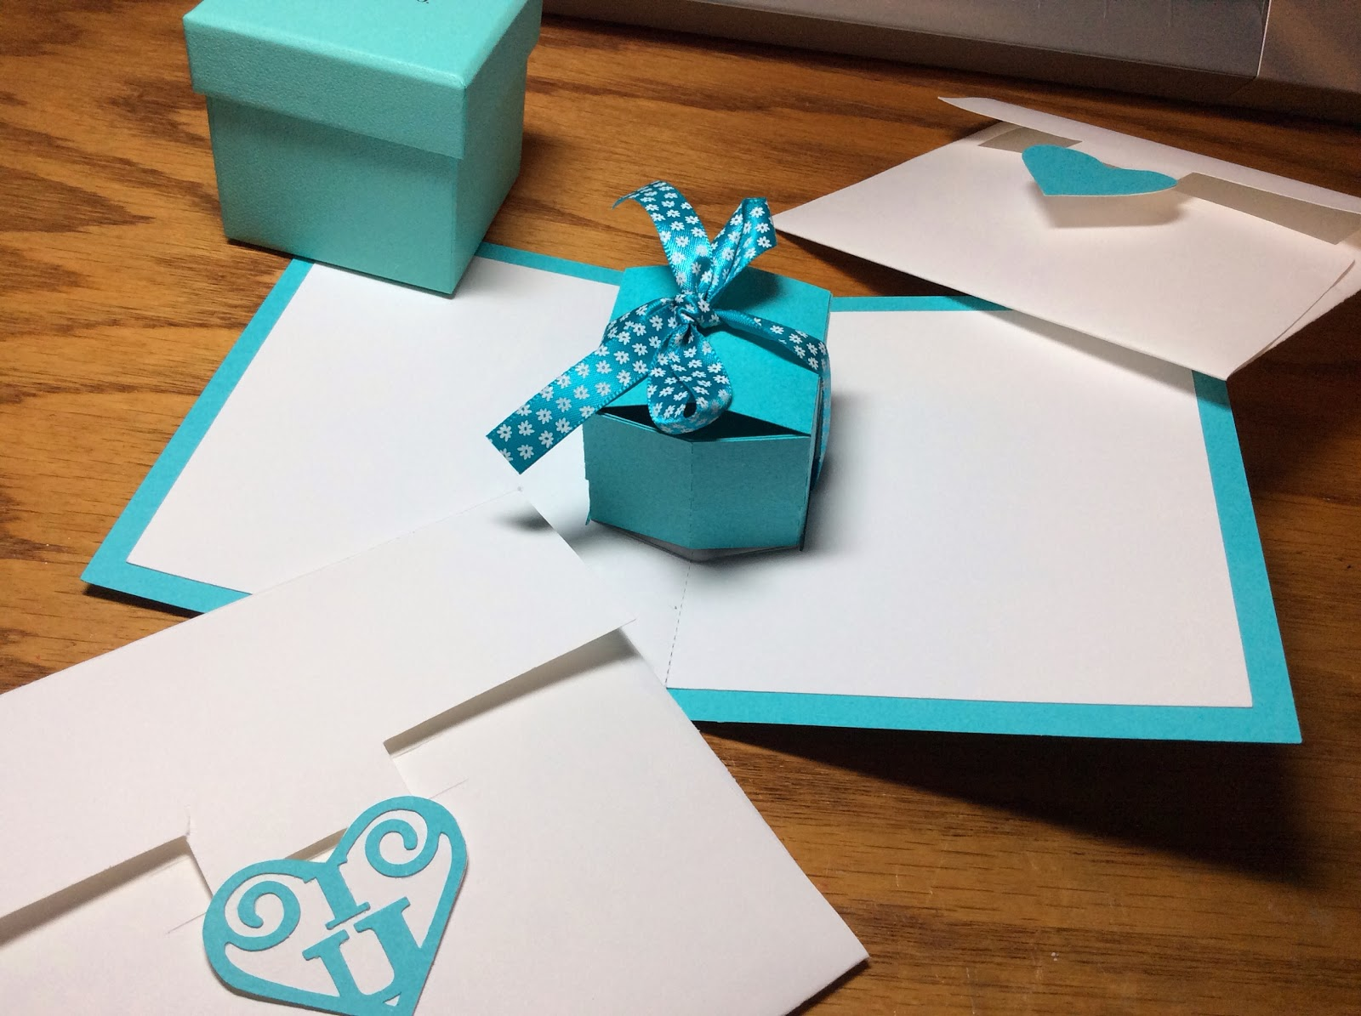

Little Blue Box of Happiness with two different heart designs for the envelope.

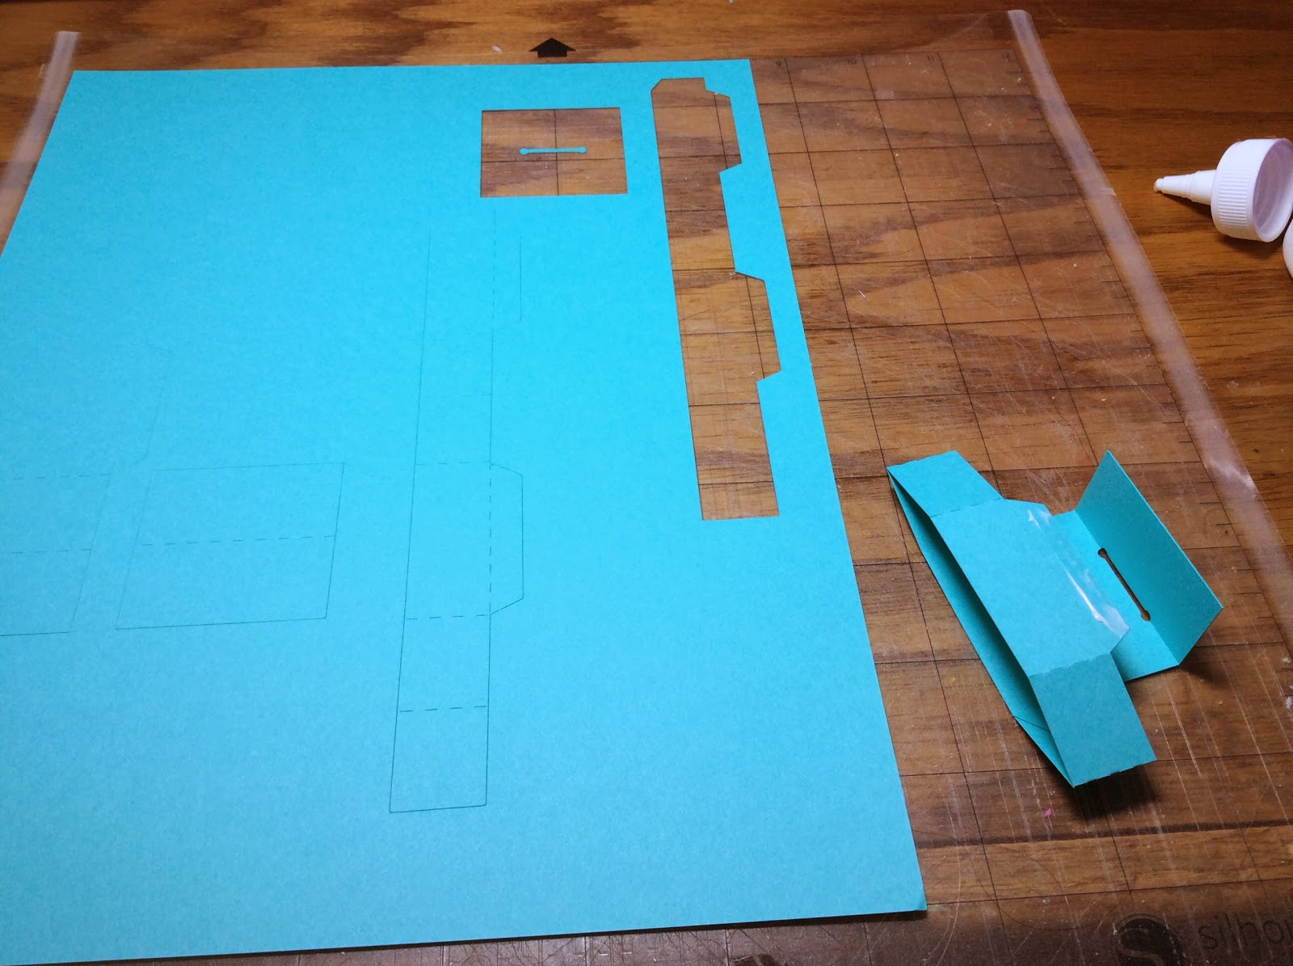

Glue the smallest box together and attach the ring insert to the tabs as shown.

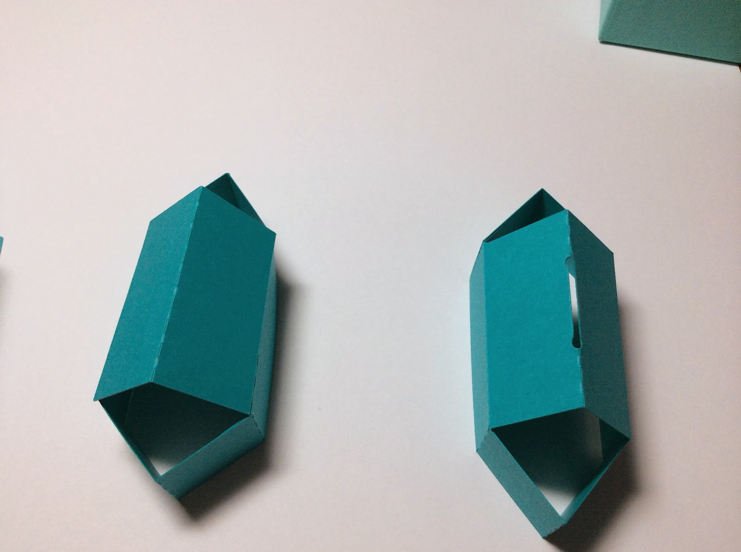

Glue the top together as shown on the left. The ring insert is on the right.

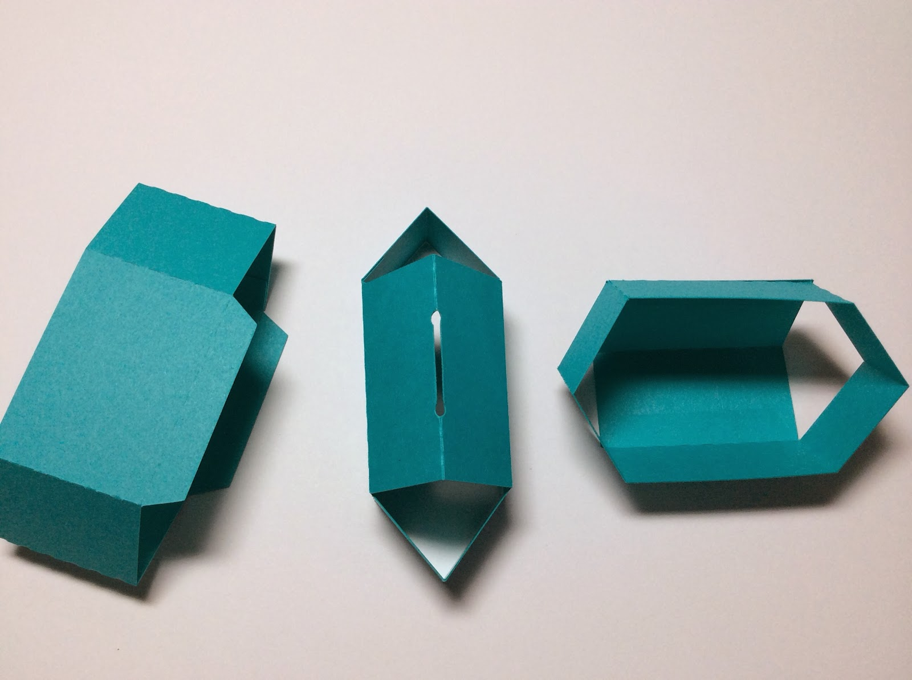

Make the bottom of the box...shown on the left.

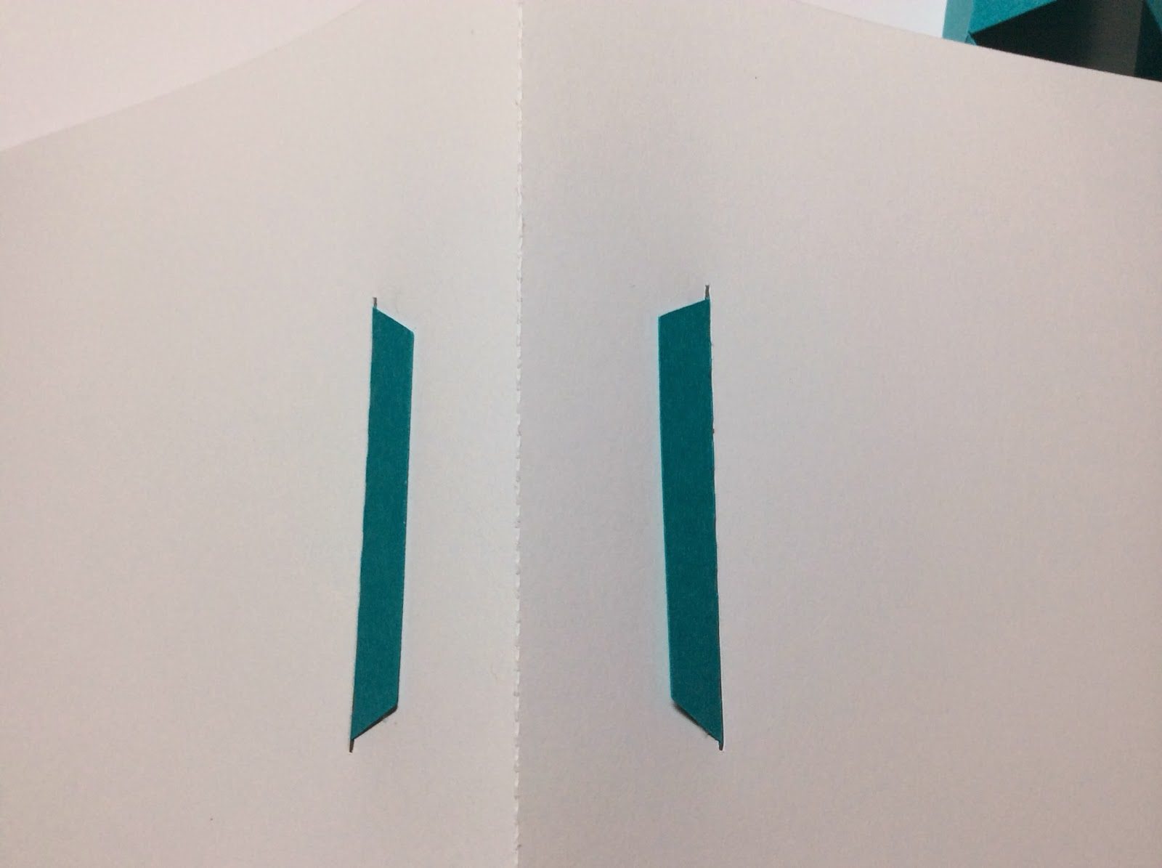

Insert the bottom of the box with the tabs INWARD...this is needed for the ribbon to be threaded on the bottom.

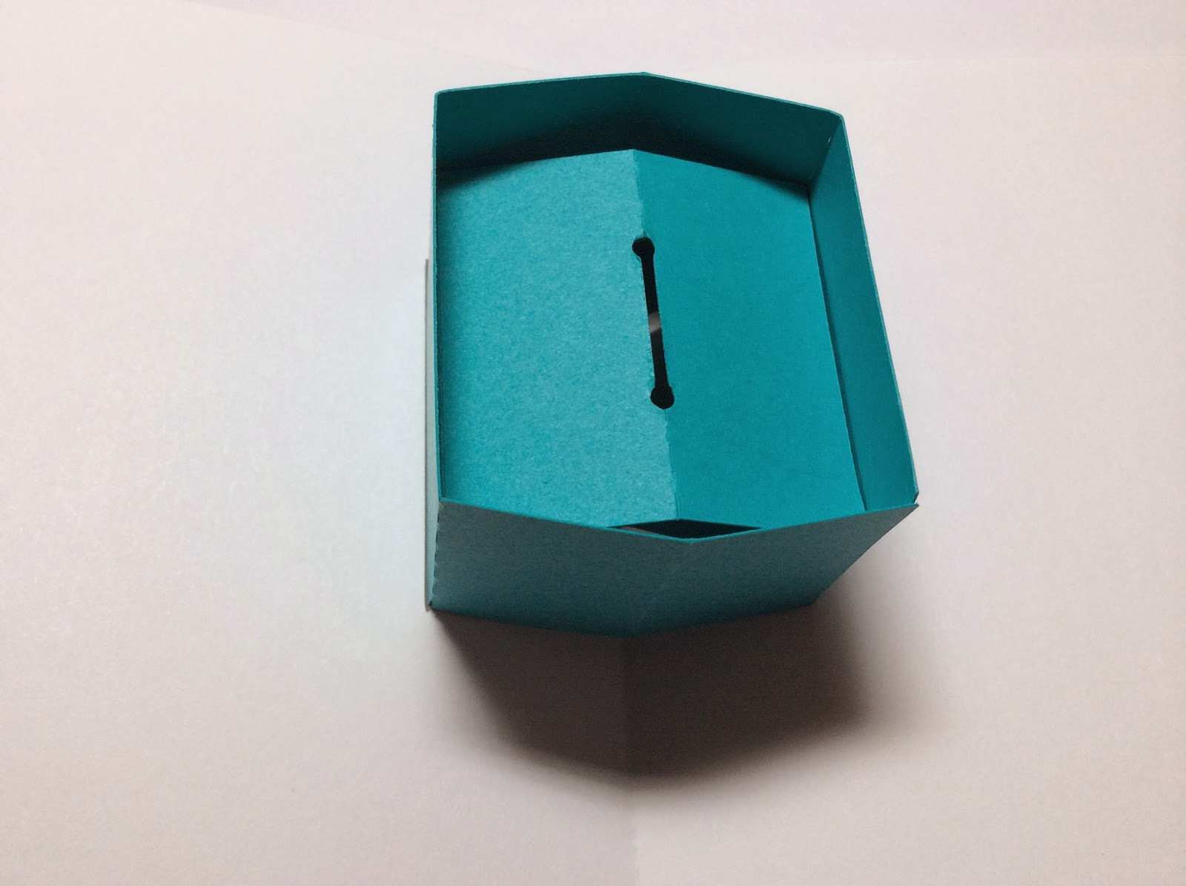

Here is what the inside of the box looks like after the ring insert has been placed inside the box.

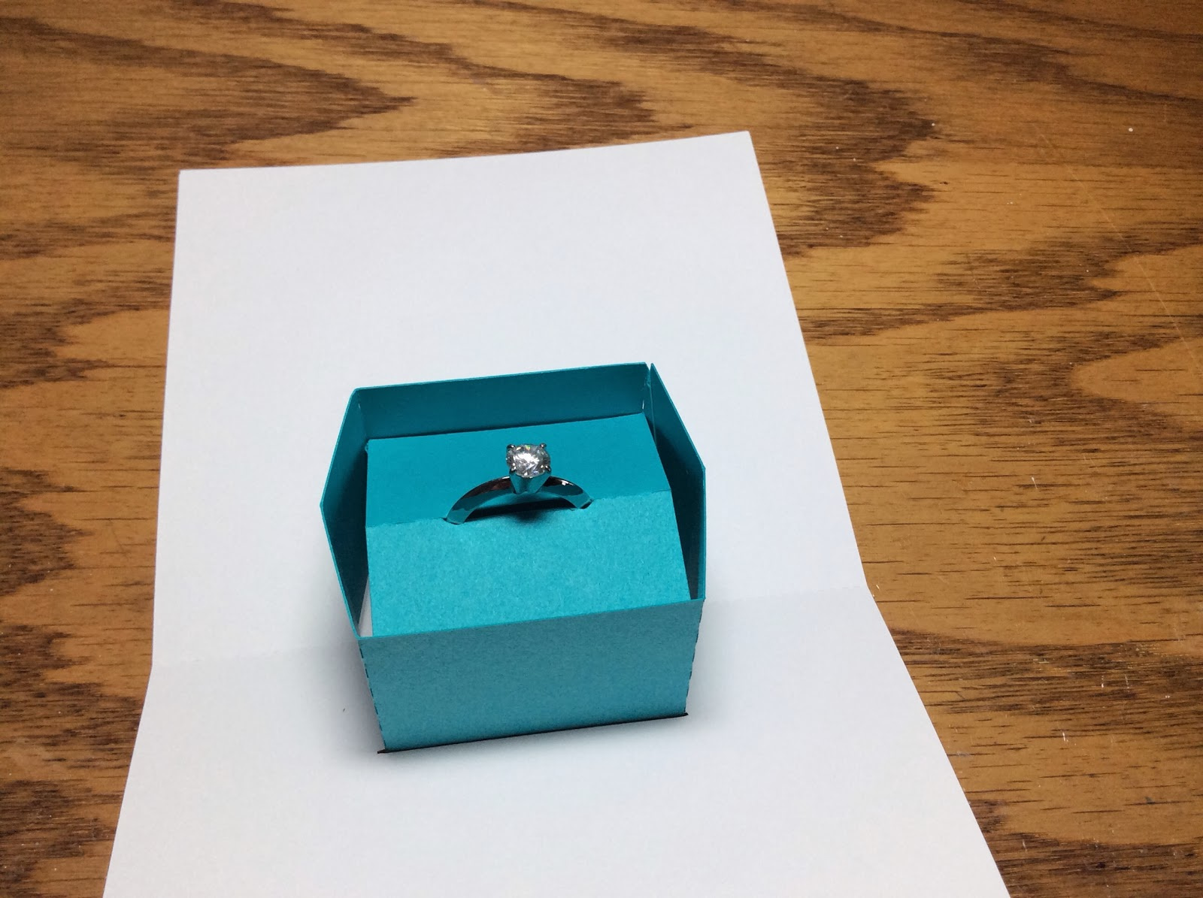

A ring can be placed inside the box.

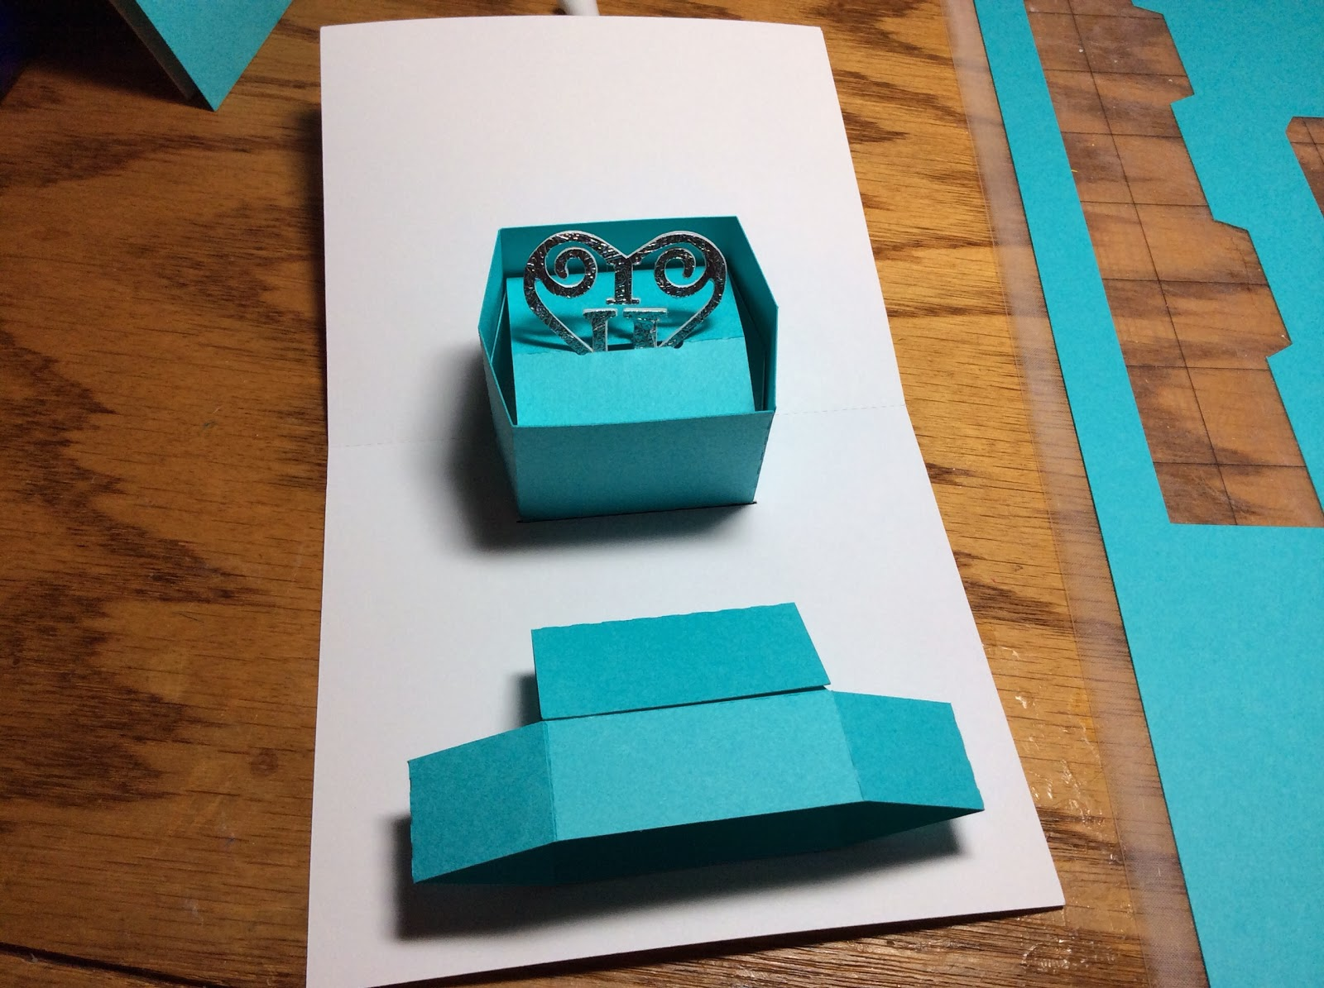

Or a charm...glue two designs together. The box cover is shown at the bottom of the above photo. Notice that the top is folded outwards. When this card is folded closed, please make sure all of the pieces fold outwards for the box to close correctly.

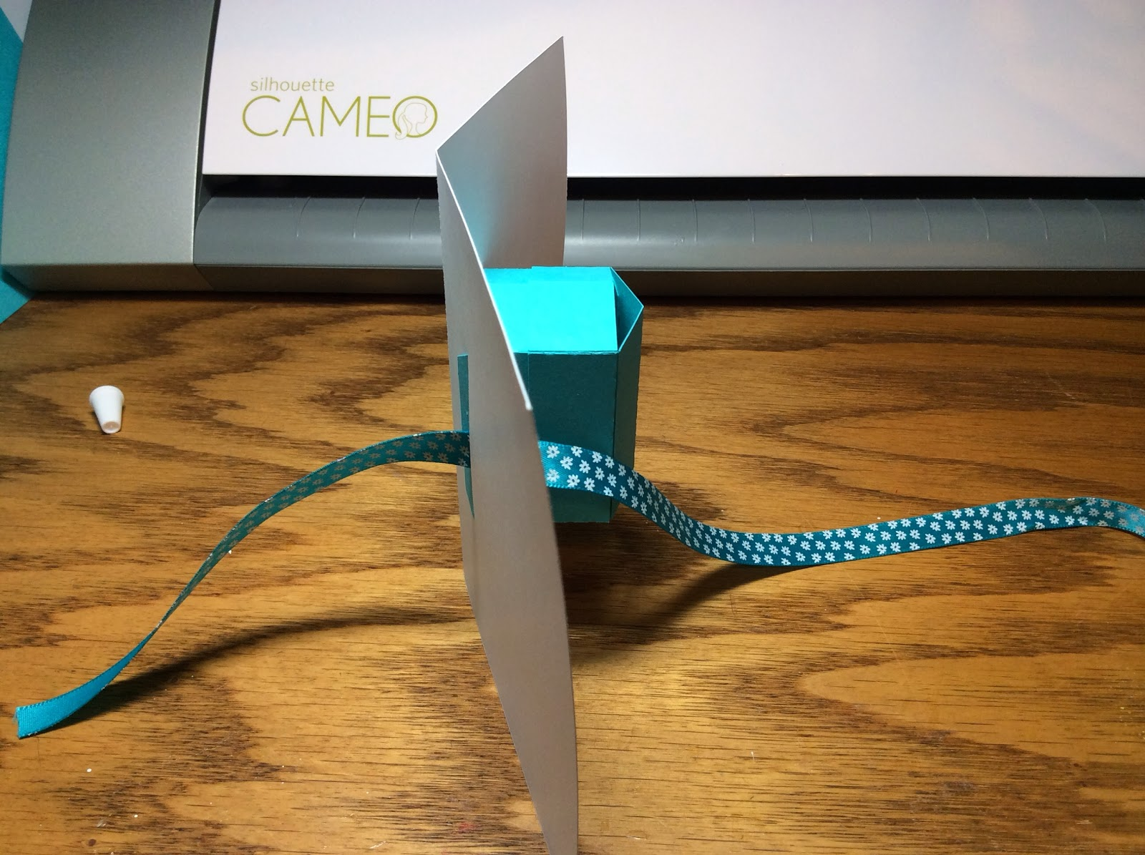

Thread an 18-inch length of ribbon through the bottom of the card and back.

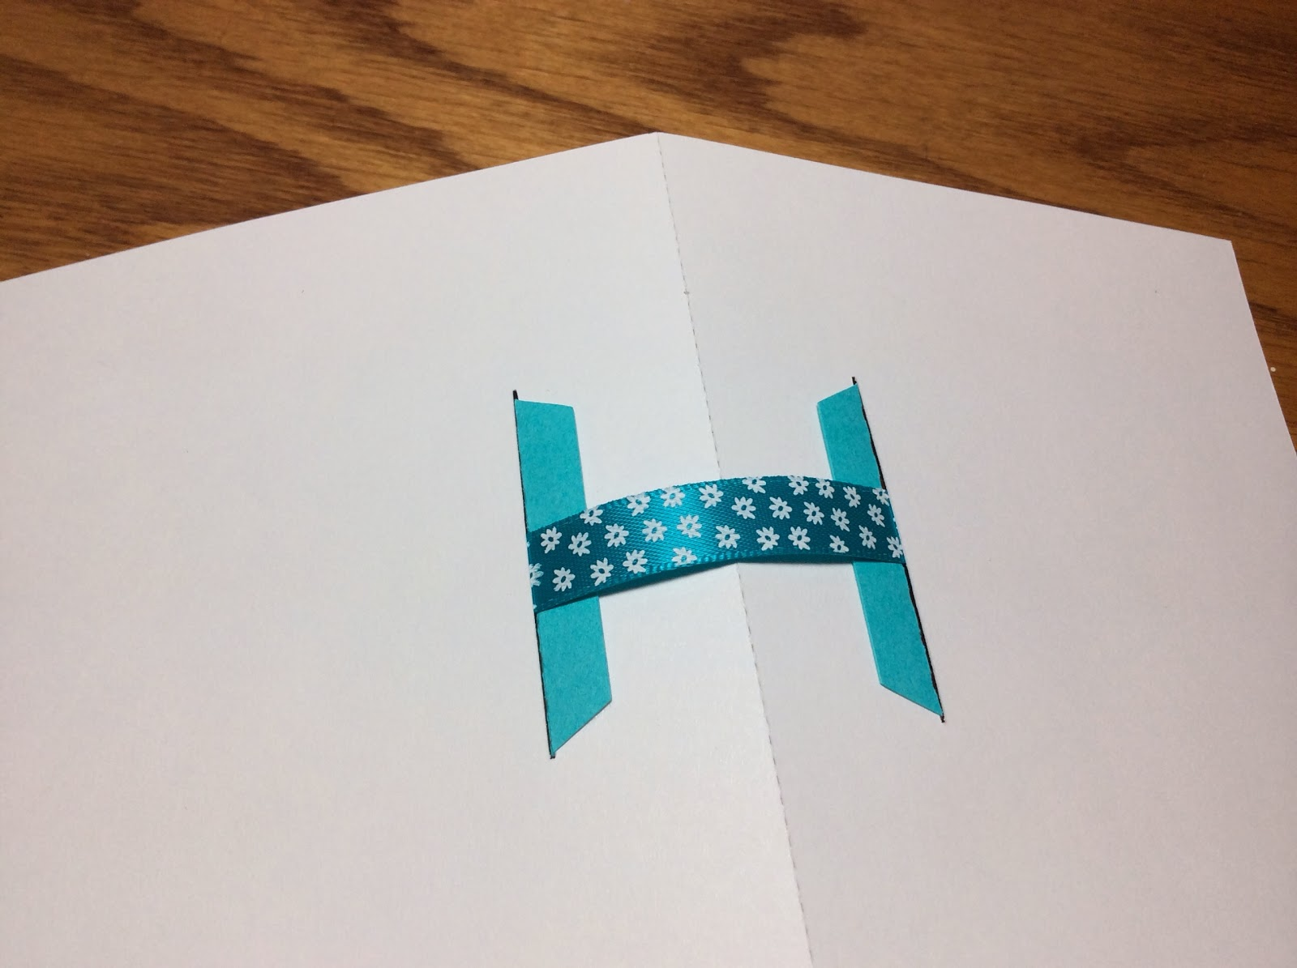

Here is what it looks like after it has been threaded through the bottom.

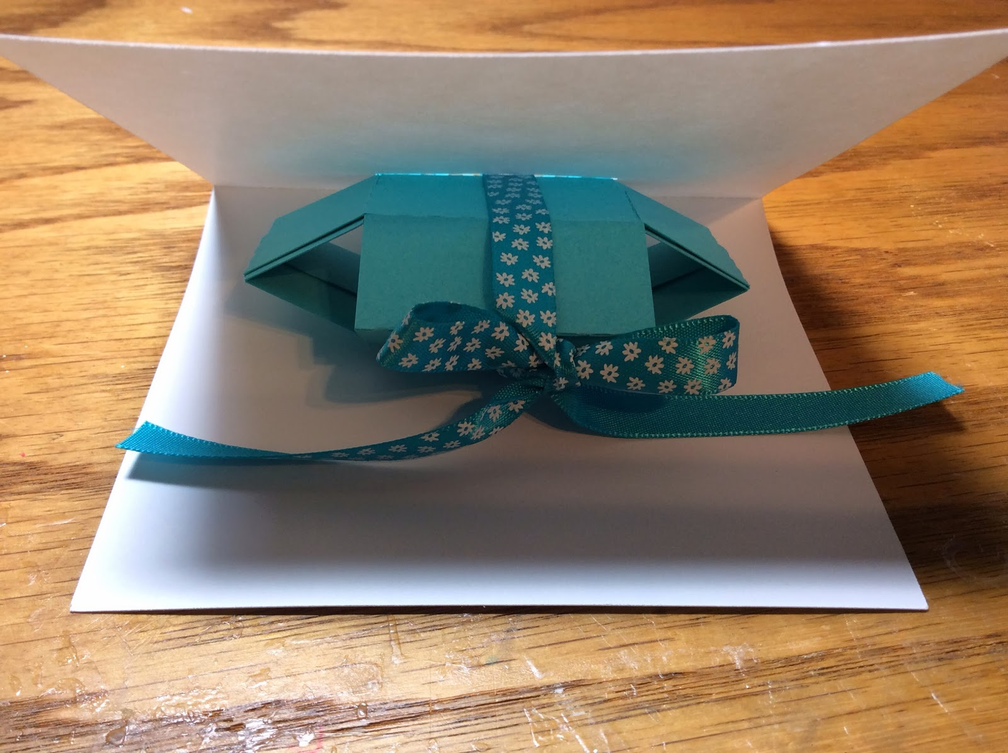

Put the top on the box and close the card partially. Tie the ribbon as shown.

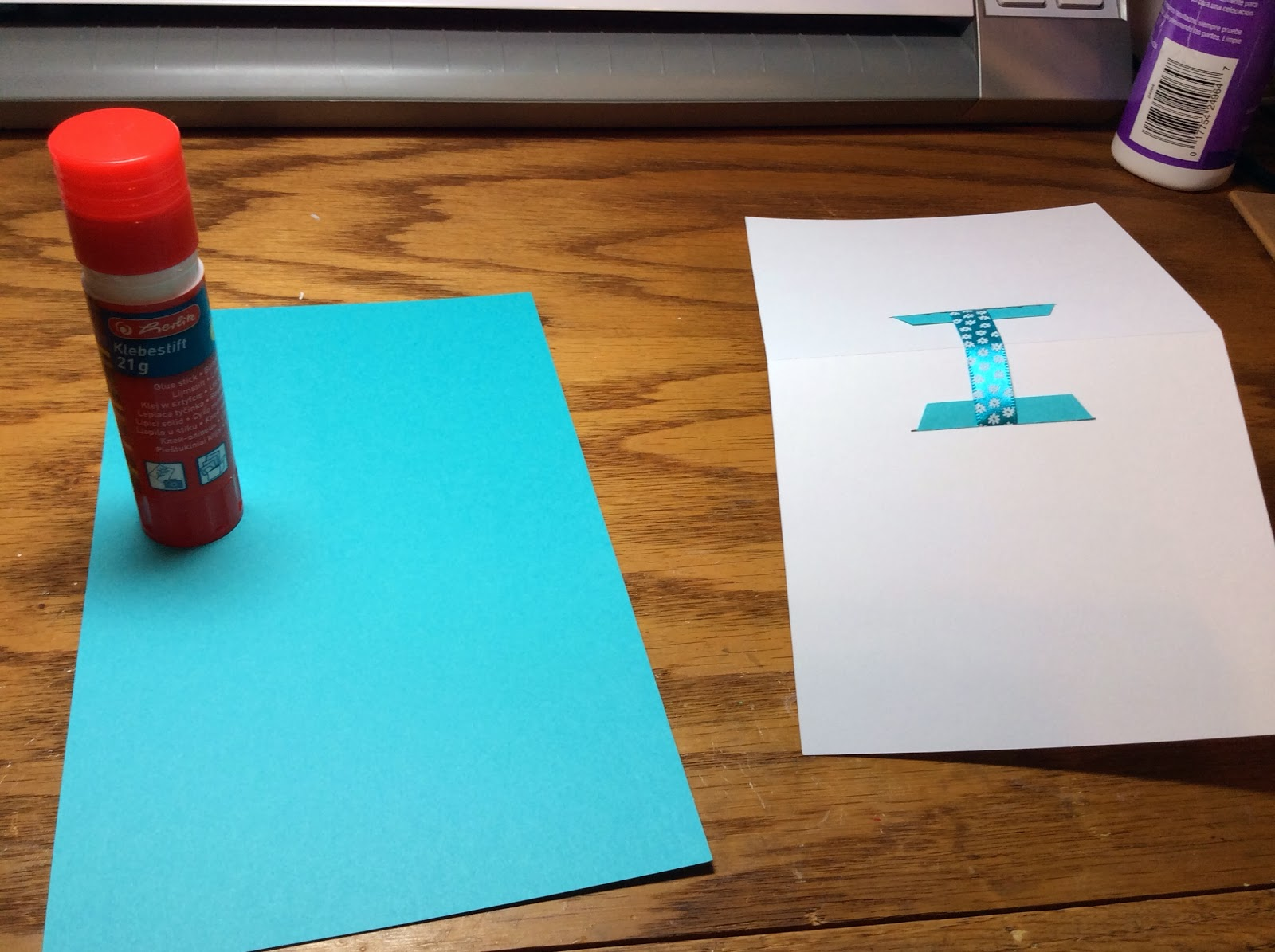

Use a glue tick to glue the contrasting color to the bottom. The glue stick will not warp the paper as much as other types of glue.

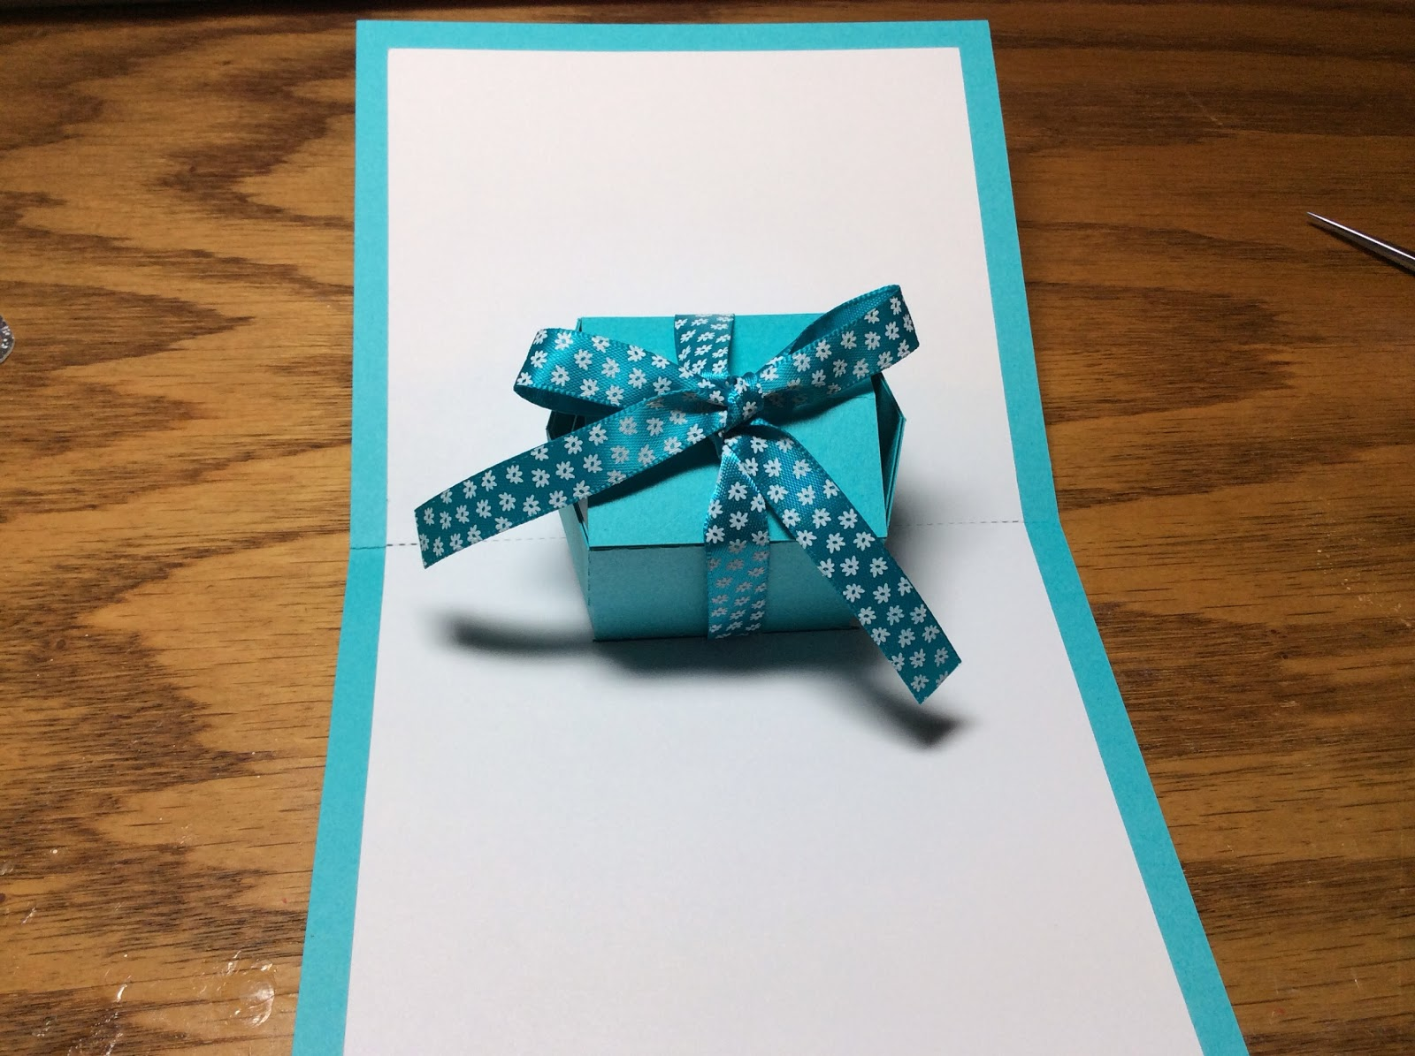

Completed pop-up box card.

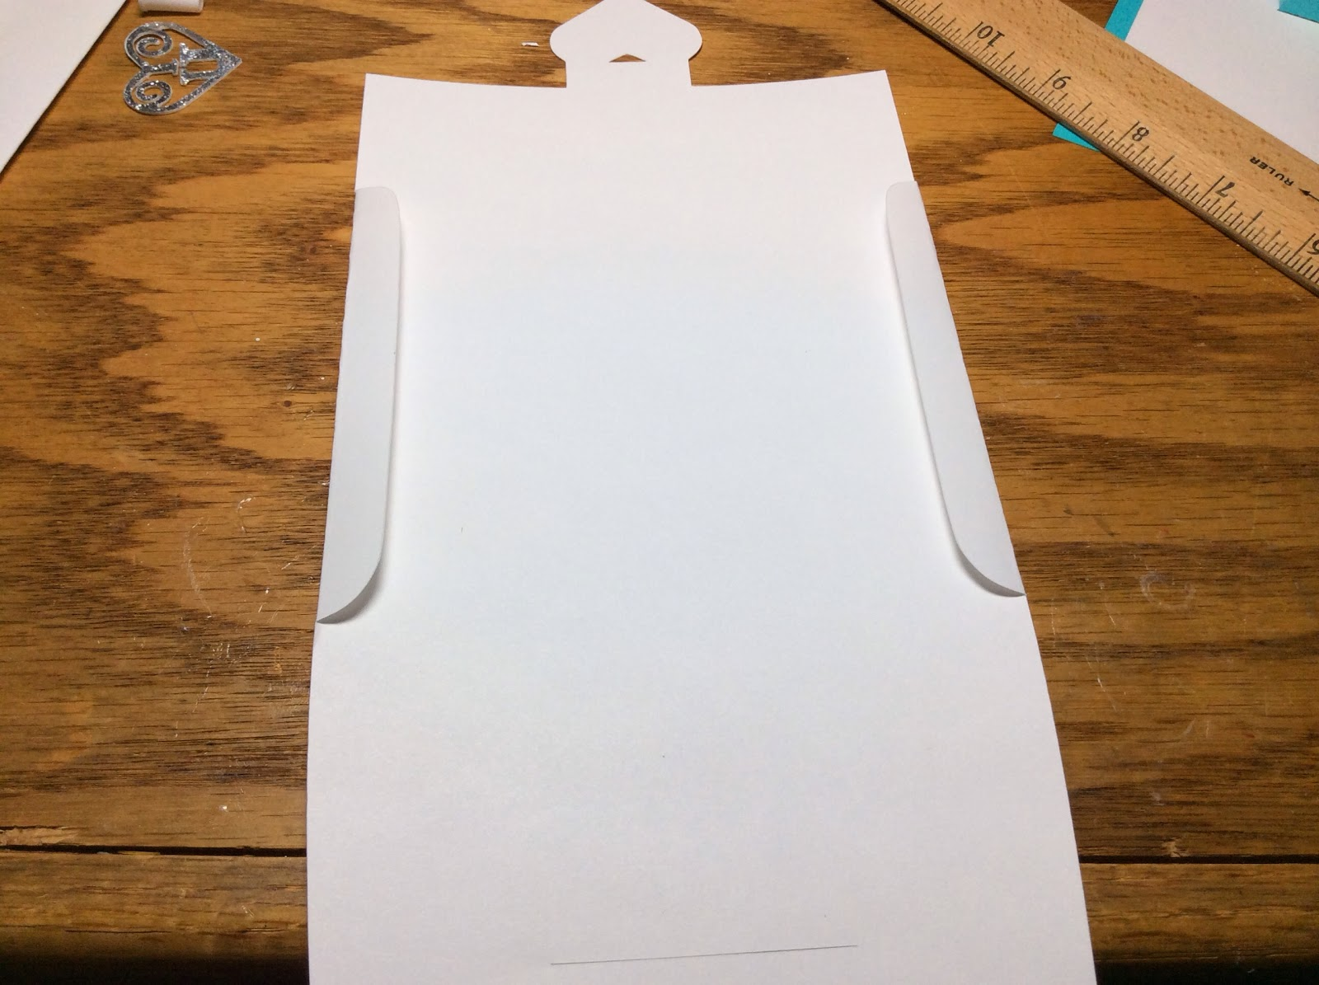

To make the envelope, fold the sides as shown.

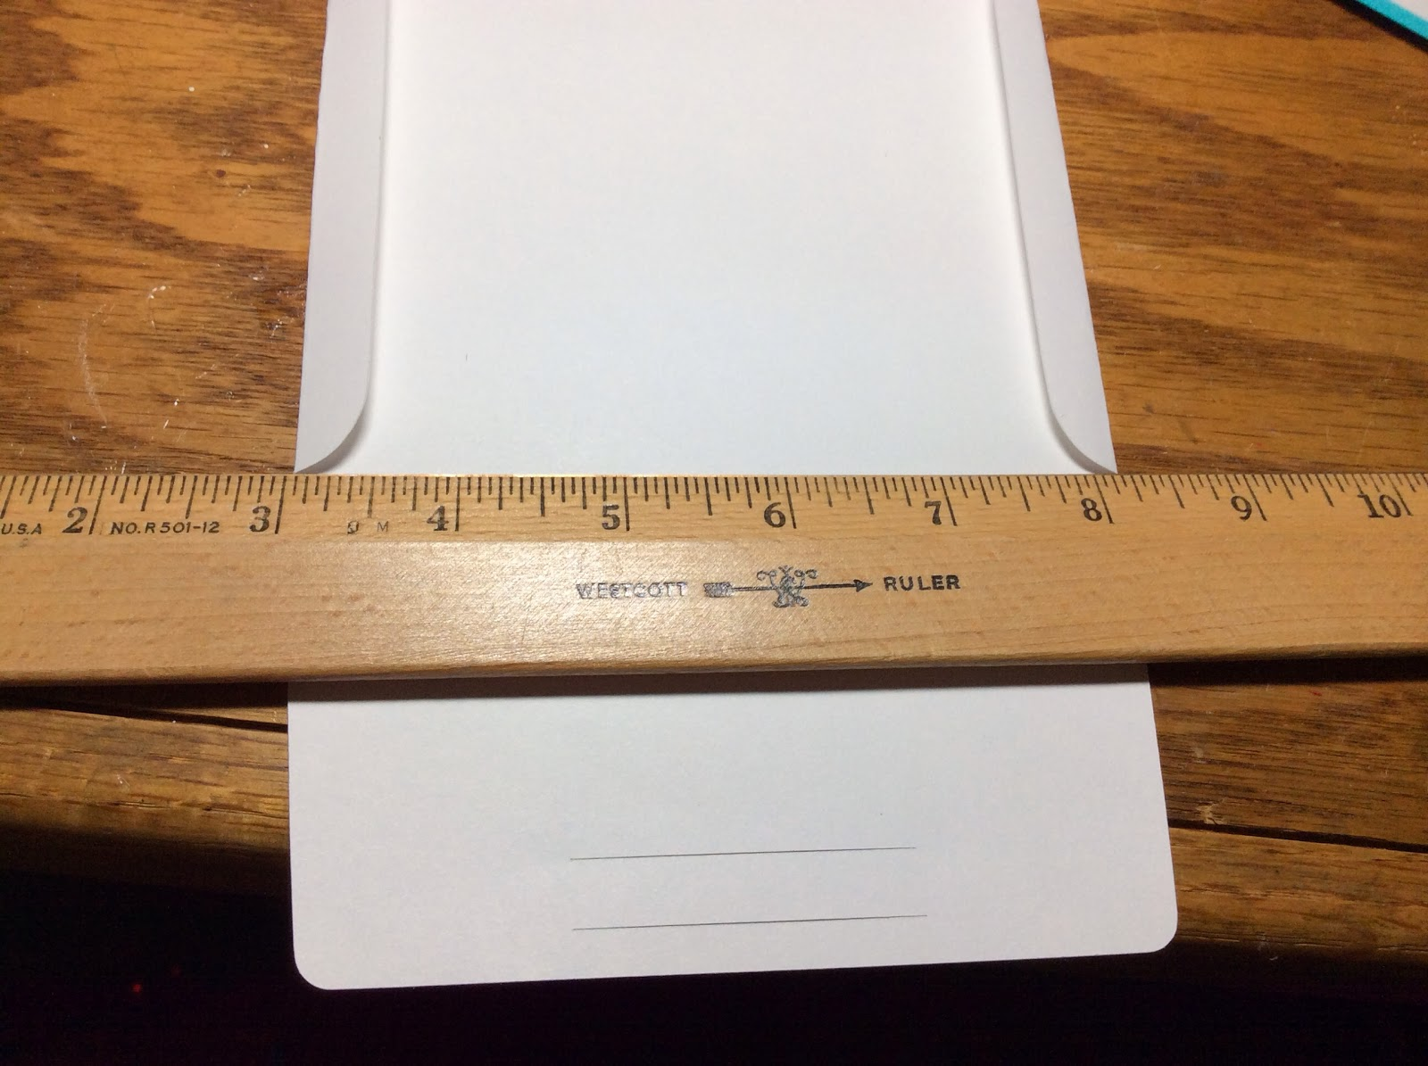

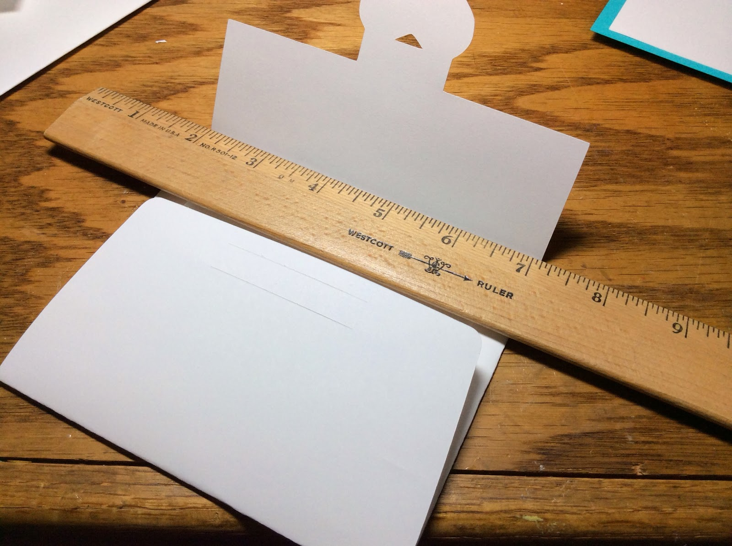

Fold the top and bottom as shown above. I used a ruler to help fold the paper in a straight line.

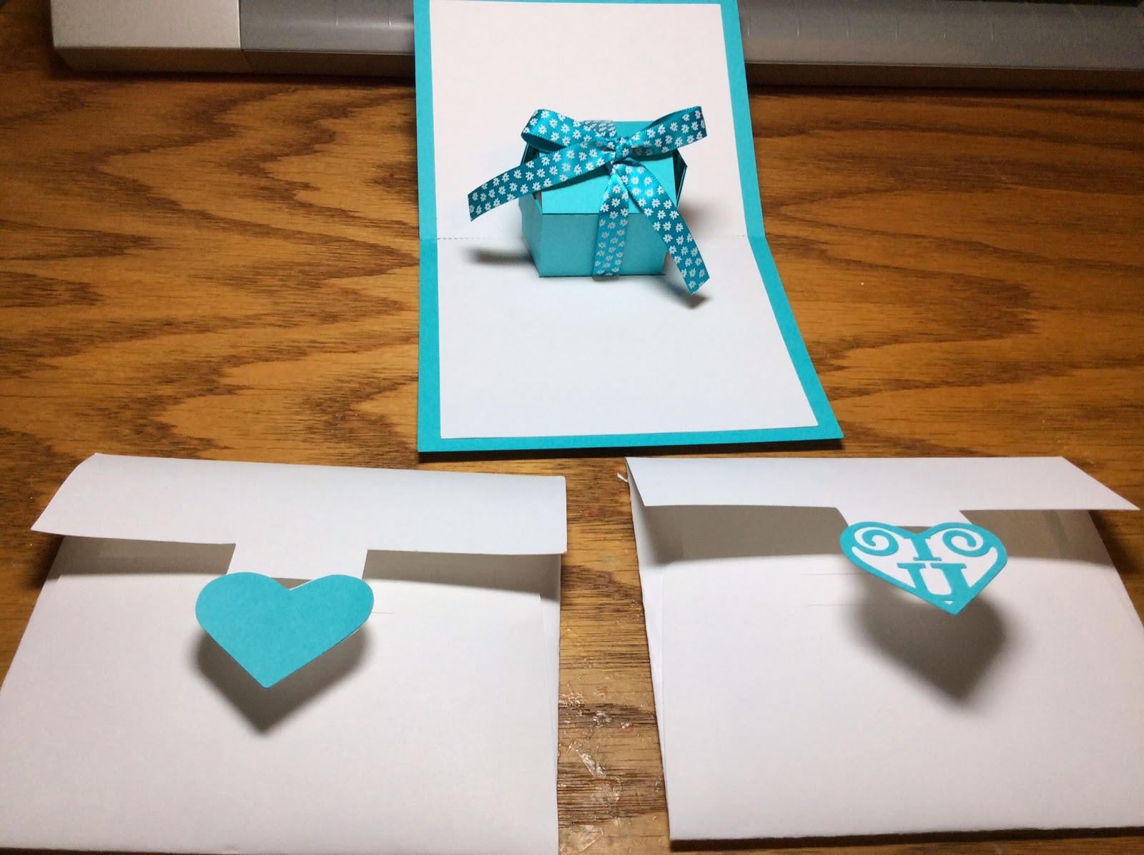

Envelopes with two different heart designs.

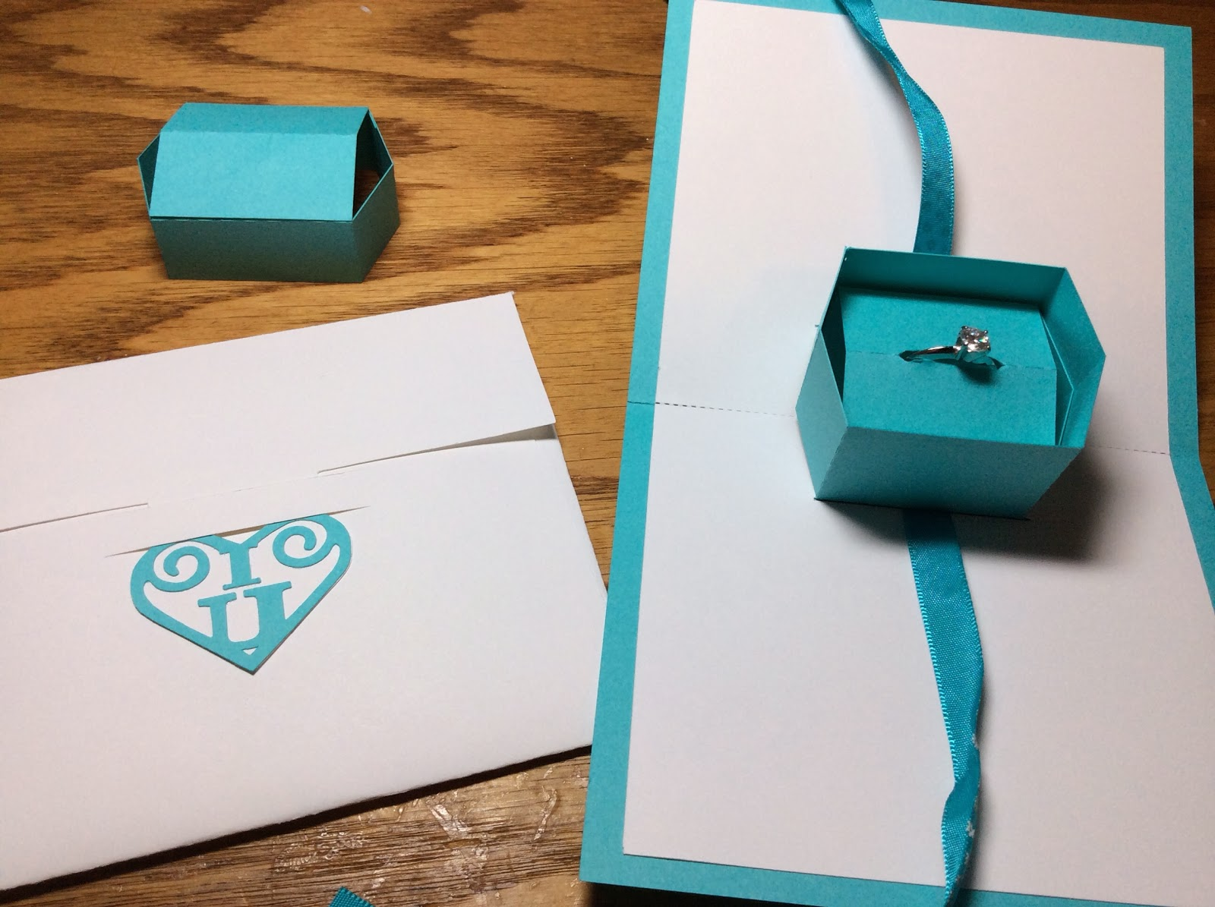

Here is what the box looks like when opened with a cubic zirconia ring in it.

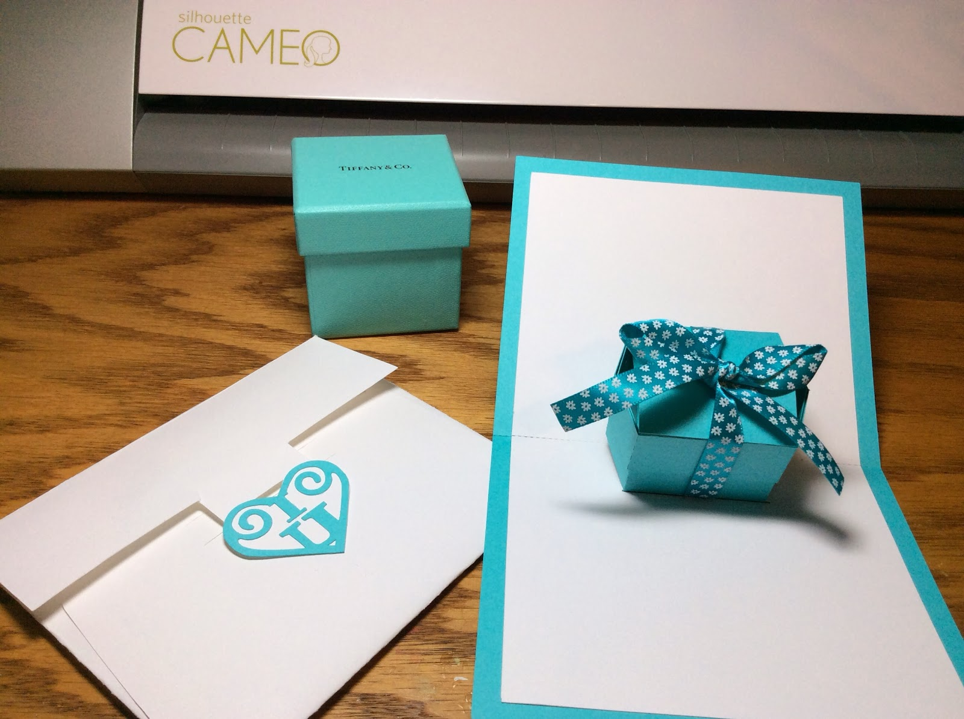

The box looks great next to the real thing!